Question #1
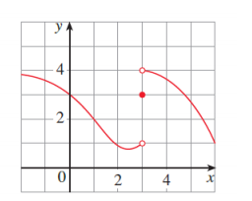
a)
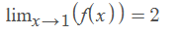
b)
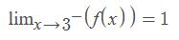
c)
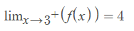
d)
Because the value of 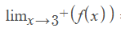is not equal to .
e) f(3) = 3

Question #2
a)
1)
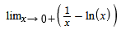
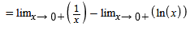
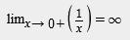

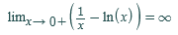
2)
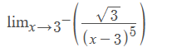
For x approaching 3 from the left , 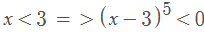
The denominator is a negative quantity approaching 0 from the left
3)
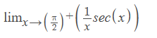
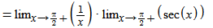
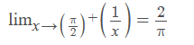
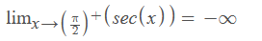
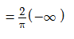
b)
4)
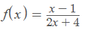
Vertical Asymptote:
2x+ 4 =0
2x=-4
x=-4/2 =-2
Therefore, vertical Asymptote is at x=-2
5)
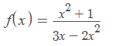
3x – 2x² = 0
x(3 – 2x) = 0
x = 0, 3 – 2x = 0
2x = 3, x = 3/2
Therefore, vertical asymptotes are x = 0, x = 3/2
Question #4
a)
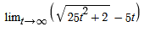
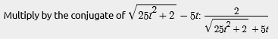
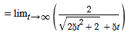
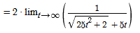
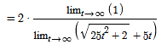
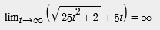
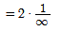
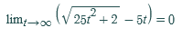
b)
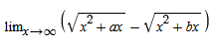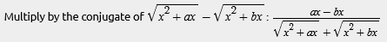
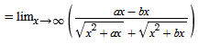
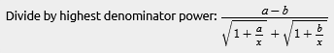
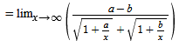
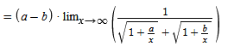

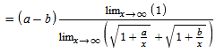
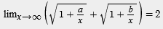
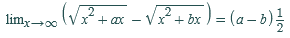
c)
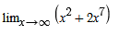

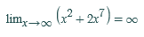
d)
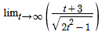
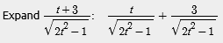
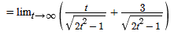

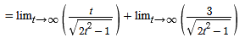
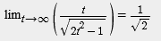
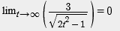
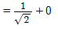
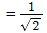
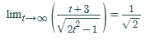
e)
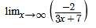
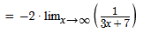
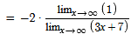
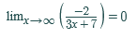

Question #5
a)
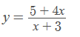
Vertical asymptote:
x + 3 = 0
x = -3
Vertical asymptote at x = -3
Horizontal Asymptote:
Here the degree of the denominator and numerator is same.
y = (4x/x)
y = 4
Therefore, horizontal asymptote is y = 4
b)
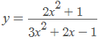
Vertical asymptote:
3x² + 2x -1 =0
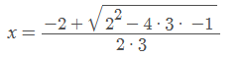, 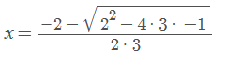
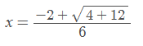, 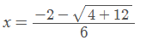
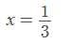, 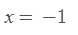
Horizontal asymptote:
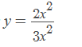
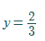
c)
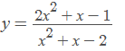
Vertical asymptote:
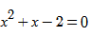
Solve with quadratic formula:
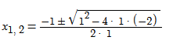
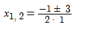
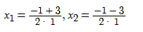
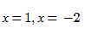
Horizontal Asymptote:
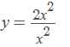

d)
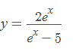
Vertical Asymptote:
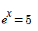
Apply exponential rule
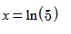
Horizontal asymptote:
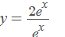
y = 2, y = 0
e)
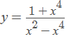
Vertical Asymptote:
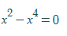
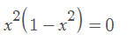
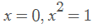
,
Vertical asymptote are x = 0, x = -1, x = 1
Horizontal Asymptote:
